**HEALTH CARE SYSTEM**

**A Project Report**

Submitted in partial fulfillment of the

Requirements for the award of the Degree of

**BACHELOR OF SCIENCE (INFORMATION TECHNOLOGY)**

**By**

Jackson Ferrao

TIT2021015

**Under the esteemed guidance of**

**Mrs. K.Sarojini**



**DEPARTMENT OF INFORMATION TECHNOLOGY**

**SIES COLLEGE OF ARTS,SCIENCE & COMMERCE(AUTONOMOUS)**

**SION(W),MUMBAI, 400022**

**MAHARASHTRA**

**2020**

**PROFORMA FOR THE APPROVAL PROJECT PROPOSAL**

**Rollno: TIT2021015**

1. Name of the Student –Jackson Ferrao
2. Title of the Project –Health Care System
3. Name of the Guide : K. Sarojini
4. Teaching experience of the Guide - yrs
5. Is this your first submission? Yes

Signature of the Student Signature of the Guide

Jackson Ferrao K. Sarojini

Date: 7th October 2020 Date: 7th October 2020

Signature of the Coordinator

K. Sarojini

Date: 7th October 2020

**SIES COLLEGE OF ARTS,SCIENCE & COMMERCE(AUTONOMOUS)**

***(Affiliated to University of Mumbai)***

**SION(W), MUMBAI-400022**

**DEPARTMENT OF INFORMATION TECHNOLOGY**



**CERTIFICATE**

This is to certify that the project entitled, **"Health Care System "**, is bonafide work of **Jackson Ferrao** bearing Seat.No: **TIT2021015** submitted in partial fulfillment of the requirements for the award of degree of BACHELOR OF SCIENCE in INFORMATION TECHNOLOGY from University of Mumbai.

**Internal Guide Coordinator**

**K. Sarojini Sudha B.**

**External Examiner**

**Date: 5th December 2020 College Seal**

**Abstract**

Going to gyms and visiting a clinic are considered to be to different things or two opposite ends of a thread. 360FIT brings everything under one roof. Earlier it was difficult for people to do such things like exercising, having a therapy session or anything else. It was also expensive also at the same time. We also have training session for the upcoming trainers, helping them to mark themselves in the fitness industry. From Calisthenics to Ayurveda are also included in the unique category in our bracket of versatility. It is also not that expensive as we have all the basic fees ducted by us itself. We also train aspiring fitness trainers who wish to be part of this fitness revolution. The website also allows people to join our franchise and promoting it. The existing systems were good and useful but, also complex at the same time. Either they were focusing on the body building aspect of fitness or medical fitness of a person. This is not the case with 360 FIT, here we focus on overall health plans of a person.

**ACKNOWLEDGEMENT**

First of all, we thank my friends for encouraging us to complete the project work successfully.

We express our sincere gratitude to our project guide Mrs. K. Sarojini, SIES College of Arts, Science & Commerce (Autonomous), Sion, for the inspiration and valuable suggestions during the course of project work.

We also thank our friends and family members for their support and encouragement throughout the course of my project.

**DECLARATION**

I hereby declare that the project entitled, “**Health Care** **System**” has not been in any case duplicated to submit to any other university for the award of any degree. To the best of my knowledge other than me, no one has submitted to any other university.

The project is done in partial fulfillment of the requirements for the award of degree of **BACHELOR OF SCIENCE (INFORMATION TECHNOLOGY)** to be submitted as final semester project as part of our curriculum.

**Name and Signature of the Student**

**Jackson Ferrao**

**Table of Contents**

**Chapter 1: Introduction 8**

**1.1 Background 10**

**1.2 Objective 11**

**1.3 Purpose, Scope and Applicability 11**

**Chapter 2: Survey of Technologies 13**

**2.1 Front-End 13**

**2.2 Back-End/DBMS 14**

**2.3 Scripting Language 16**

**2.4 Software and Broad Areas of Application 17**

**Chapter 3: Requirement and Analysis 18**

**3.1 Problem Definition:- 18**

**3.2 Requirement Specification: 19**

3.3 Planning & Scheduling: 19

**Chapter 4: System Design 28**

**4.1 Basic Modules: 28**

**4.2 Data Design: 28**

**4.3 User Interface Design: 33**

**References 36**

**List of Tables**

**Table 2.1 : Software and Broad Areas of Application……………………………………17**

**Table 3.1 : Pert Chart (Documentation)…………………………………………………..20**

**Table 3.2 : Pert Chart (Project)……………………………………………………………21**

**List OF Figures**

**Figure 3.1 : Gantt Chart(Project)….………………………………………………………23**

**Figure 3.2 : Gantt Chart(Documentation)...………………………………………………23**

**Figure 3.3 : ER Diagram……………………………………………………………………25**

**Figure 3.4 : Activity Diagram………………………………………………………………26**

**Figure 3.5 : Use Case Diagram……………………………………………………………..37**

**Chapter 1: Introduction**

# **Background**

360 FIT is fitness website which not only focuses on physical health of a person but also internal health like giving psychiatric, sleep, diet plans, etc.. Since people are avoiding health issues and giving more importance to life success such a website needed a place on the internet. Consumers can directly log-in to the page by paying a specific amount. Once they have done this now they can access as many programs as they want. This program includes gym training, Doctor’s consultation, nutritionist’s consultation, etc. Customers will have to pay for each functionality they would like to access. Here we are speaking about the customers but, people who use the website for joining 360 FIT as an aspiring fitness trainers are also considered as customers. We also train aspiring fitness trainers who wish to be part of this fitness revolution. The website also allows people to join our franchise and promoting it. The existing systems were good and useful but, also complex at the same time. Either they were focusing on the body building aspect of fitness or medical fitness of a person. This is not the case with 360 FIT, here we focus on overall health plans of a person.

# **Objective**

* A website that will provide help for all fitness related queries.
* Provides education for fitness trainers.
* Allows people to grow business but, as per the franchise laws.
* To provide online classes for fitness training.
* Doctors available for 24hrs help in case of emergency.
* Also focuses on Ayurveda in order to promote Indian knowledge.
* The foremost feature of the proposed system is giving access the users for online training, consultation, etc.
* Lists the available consultation and therapy programs.
* Ayurveda can also be consulted.
* Fitness trainers are also educated with certification.
* Proper schedule for appoinments

# **Purpose, Scope and Applicability**

* + 1. **Purpose**

This system will guide people towards healthy life style. Since people are ignoring it due to busy co-operate living or hectic schedule. This website has been made in consideration with other popular websites like cure.fit, nitro, etc. But this website has a fusion of them not completely dependent on either of their modules and features.

**1.3.2 Scope**

It stores all the appointments and schedule of the user. This stored data of schedule will be displayed in the form of table for user and the granted admin .Can not only consult a doctor but, also a ayurvedic expert. Provides an option to join the franchise, to do so the user will have to fill a form showing his networth. If the networth matches the requirements then they can promote the business of the website under specific laws. There are also online classes conducted via zoom meetings. The zoom links will be displayed in the schedule. Doctors consultation will also be done similarly.

**1.3.3 Applicability**

The proposed system is willing to mainly target the youth, senior citizens and people who don’t have much time to be fit.

# **Chapter 2: Survey of Technologies**

# **2.1 Front-End**

1. **Java**: -

* Simple: Java is very easy to learn, and its syntax is simple, clean and easy to understand. According to Sun, Java language is a simple programming language
* Object – oriented: Java is an [object-oriented](https://www.javatpoint.com/java-oops-concepts) programming language. Everything in Java is an object. Object-oriented means we organize our software as a combination of different types of objects that incorporates both data and behaviour.
* Platform – Independent: Java is platform independent because it is different from other languages like [C](https://www.javatpoint.com/c-programming-language-tutorial), [C++](https://www.javatpoint.com/cpp-tutorial), etc. which are compiled into platform specific machines while Java is a write once, run anywhere language. A platform is the hardware or software environment in which a program runs.
* Architecture – neutral: Java is architecture neutral because there are no implementation dependent features, for example, the size of primitive types is fixed.
* Dynamic: Java is a dynamic language. It supports dynamic loading of classes. It means classes are loaded on demand. It also supports functions from its native languages, i.e., C and C++.

#### .

2. **HTML (Hyper Text Mark Up Language)**: -

* It is the language which can be easily understood and can be modified.
* Effective presentations can be made with the HTML with the help of its all formatting tags.
* It provides the more flexible way to deign web pages along with the text
* Links can also be added to the web pages so it helps the readers to browse the information of their interest.
* Graphics, videos and sounds can also be added to the web pages which give an extra attractive look to your web pages.

**Why we choose Bootstrap?**

**Bootstrap**:

### Easy to use: Anybody with just basic knowledge of HTML and CSS can start using Bootstrap.

### Responsive features: Bootstrap's responsive CSS adjusts to phones, tablets, and desktops.

### Mobile-Friendly: Mobile-first approach: In Bootstrap 3, mobile-first styles are part of the core framework.

### Simple Integration: Bootstrap can be simply integrated along with distinct other platforms and frameworks, on existing sites and new ones too and one more things you can also utilize particular elements of Bootstrap along with your current CSS.

### Customizable Bootstrap: The Bootstrap can be customized as per the designs of your project.

# **Back-End/DBMS**

### IIS server:

### A Microsoft product, IIS is a server that offers all the features such as

* Since it’s not an open source, adding personal modules as well as modifying becomes a bit difficult.
* It supports all the platforms that run Windows operating system. Additionally, you also get good customer support, if there is any issue.
* This module ensures the security and manageability. Due to this feature you can now use greylisting and access patterns enabling you to smoothly and dynamically manage access for number of sites to the internet and FTP servers.
* Allows you to build more interactive and powerful web applications because of a continuous and bidirectional communication between the web browser and the web server. Web Sockets require Windows Server 2012 or higher versions.

### **Node.js server**:

* Node.js is basically a server-side JavaScript environment that is used for network applications such as web servers.
* It is mainly a cross-platform runtime environment for building network applications.
* Node.js also helps in understanding the difference in web development stacks.
* Build scalable real-time applications and infrastructure with Node.js, writing code using familiar JavaScript conventions.
* Create applications that can handle thousands of users with Node’s low-latency, high-volume API. Rapidly build your next big idea with Node’s rich ecosystem that grows with you.

**Why we choose SQL?**

* Can contain SQL Procedural Language statements and features which support the implementation of control-flow logic around traditional static and dynamic SQL statements.
* Support nested functions calls to other SQL functions or functions implemented in other languages.
* Reside in the database and are automatically backed up and restored as part of backup and restore operations.
* Can be invoked wherever expressions in an SQL statement are supported.
* Are easy to implement, because they use a simple high-level, strongly typed language

# **Scripting Language**

1. **JavaScript**:

* JavaScript is very useful while using forms. It has the capability to validate user input for errors and also saves time. If the user leaves a required field empty or the information is incorrect, JavaScript checks for them before sending the data over to the server.
* Since JavaScript is a client-side technology, it can perform basic calculations on the browser. The browser does not need to ask server time for every task. This is especially helpful when a user needs to perform these calculations repeatedly.
* JavaScript provides greater control to the browser rather than being completely dependent on the web servers. JavaScript provides various browsers with additional functionalities that help reduce server load and network traffic.
* Unlike other programming languages, JavaScript has built-in functions to determine the date and time.
* JavaScript has very handy features to dynamically generate HTML content for the web. It allows us to add text, links, images, tables, etc after an event occurrence.

### VBscript :

* VBScript is a lightweight scripting language, which has a lightning fast interpreter.
* VBScript, for the most part, is case insensitive. It has a very simple syntax, easy to learn and to implement.
* Unlike C++ or Java, VBScript is an object-based scripting language and NOT an Object-Oriented Programming language.
* It uses Component Object Model (COM) in order to access the elements of the environment in which it is executing.
* Successful execution of VBScript can happen only if it is executed in Host Environment such as Internet Explorer (IE), Internet Information Services (IIS) and Windows Scripting Host (WSH).

# **Software and Broad Areas of Application**

Table 2.1 : Software and Broad Areas of Application

|  |  |
| --- | --- |
| **FRONT-END / GUI Tools** | Bootstrap |
| **DBMS/BACK-END** | Php, SQL |
| **SCRIPTING LANGUAGES** | JavaScript |

# **Chapter 3: Requirement and Analysis**

# **Problem Definition:-**

## False Results:

## If you search terms like “nausea,” “fatigue,” “abdominal pain,” and “sore joints,” you’ll find a wide variety of possible diagnoses, from minor issues to life threatening conditions. When you use an online symptom checker, you might struggle ruling out these differential diagnoses —leading to increased stress, fear, and anxiety. Unfortunately, there is a well-recognized connection between anxiety and pain. Your increased anxiety might worsen your pain and other symptoms. This is due to lack of specialised doctors or lack of research done by other websites.

## 

* **Expensive:**

They charge a lot of money. There is not subscription as such which makes it much more cost much more high. Users have to pay money for each consultation’s check up separately. Healthcare costs of these websites have been rising for past few years and are expected to keep increasing.

* **Lengthy Process:**

The process of administering the symptoms is a lengthy one. It can take several weeks to complete the cycle by evaluating the results, then collecting and analyzing the them, to sharing reports and acting on the results obtained. As doctors do not receive results quickly, valuable time is lost in responding to patient concerned and implementing possible changes.

* **Limited Flexibility:**

The use of data generated after the consultation i.e. results aren’t very flexible and needs to be acted on. This can take a lot of time and is often regarded as needless, neglecting the fact that it can provide some important statistic.

# **Requirement Specification:**

1. **Secure login:**

There should be a strong authentication and verification of the data entered in every field of the login form. There should not be any chance for the intruder to access the database by using SQL Injection in login form or some other technique. SQL injection is a code injection technique that might destroy your database. SQL injection is one of the most common web hacking techniques.

1. **Web Design:**

Several factors such as consistency, colours, typography, imagery, simplicity and functionality all contribute to good website design. When designing a website there are many key factors that will contribute to how it is perceived. A well designed website can help build trust and guide visitors to take action.

1. **Dynamic:**

Users need not use any other application because it has all the required features. The system which is to be developed should be easy access to anyone who has basic knowledge of using a computer.

## **3.3 Planning & Scheduling:**

### PERT Chart:

A PERT chart is a [project management](https://www.investopedia.com/terms/p/project-management.asp) tool that provides a graphical representation of a project's timeline. The Program Evaluation Review Technique (PERT) breaks down the individual tasks of a project for analysis. PERT charts are considered preferable to [Gantt charts](https://www.investopedia.com/terms/g/gantt-chart.asp) because they identify task dependencies.

PERT charts help project managers get a handle on complex projects. They’re useful because they provide an estimation of how much time you’ll need to [schedule the project](https://www.projectmanager.com/blog/what-is-project-scheduling) and what resources will be required. The nature of the PERT chart and its breakdown structure helps to visualize the complexity of a project and the dependencies between each step in the process.

PERT Diagram could be represented in two ways:

1. Activity on Arrow
2. Activity on Node

In Activity on Arrow, the arrows represent activity whereas in Activity on Node, the nodes represent activities. In the project, Activity on Node is used to draw the PERT Diagram. Here we are going to show 2 charts: one showing the schedule of the documentation (A) and the other shows the schedule of the project starting with planning to the actual implementation (B).

**(A): PERT Diagram for Documentation**

Synopsis – A

Chapter 1 – B

Chapter 2 – C

Chapter 3 – D

Table 3.1 : Pert Chart (Documentation)

|  |  |  |
| --- | --- | --- |
| Activity | Precedence | Duration |
| A | - | 2 Weeks |
| B | A | 1 Week |
| C | B | 2 Weeks |
| D | C | 1 Week |

Project Network:

Start A B C D Stop

|  |  |  |
| --- | --- | --- |
| A | 0 | 2 |
| t | 0 | 2 |
| S | 0 |  |

|  |  |  |
| --- | --- | --- |
| B | 2 | 3 |
| t | 2 | 3 |
| S | 0 |  |

Start

|  |  |  |
| --- | --- | --- |
| D | 5 | 6 |
| t | 5 | 6 |
| S | 0 |  |

|  |  |  |
| --- | --- | --- |
| C | 3 | 5 |
| t | 3 | 5 |
| S | 0 |  |

Stop

Slack = 0 for all activities

Therefore, critical path = A-B-C-D

The Project Documentation completion duration is 6weeks.

**(B): PERT Diagram for Project**

Planning – I

Requirements – II

Designing – III

Documentation – IV

Table 3.2 : Pert Chart (Project)

|  |  |  |
| --- | --- | --- |
| Activity | Precedence | Duration |
| I | - | 2 Weeks |
| II | I | 2 Week |
| III | II | 5 Weeks |
| IV | III | 6 Weeks |

Project Network:

Start I II III IV Stop

|  |  |  |
| --- | --- | --- |
| I | 0 | 2 |
| t | 0 | 2 |
| S | 0 |  |

|  |  |  |
| --- | --- | --- |
| II | 2 | 4 |
| t | 2 | 4 |
| S | 0 |  |

Start

|  |  |  |
| --- | --- | --- |
| IV | 9 | 15 |
| t | 9 | 15 |
| S | 0 |  |

|  |  |  |
| --- | --- | --- |
| III | 4 | 9 |
| t | 4 | 9 |
| S | 0 |  |

Stop

Slack = 0 for all activities

Therefore, critical path = I-II-III-IV

The Project completion duration is 15weeks.

**Gantt Chart :**

A Gantt chart, commonly used in project management, is one of the most popular and useful ways of showing activities (tasks or events) displayed against time. On the left of the chart is a list of the activities and along the top is a suitable time scale. Each activity is represented by a bar; the position and length of the bar reflects the start date, duration and end date of the activity. Below Gantt chart shows us the schedule of the project. It is a diagram representing the time taken for each task and can be easily prepared using Microsoft Word and Excel as well as some online applications. These types of charts help in the scheduling of the project after proper planning of the project is done. This scheduling helps to find out the estimated and the actual time period of each stage of the project. Here we are going to see 2 Gantt charts: one showing the schedule of the documentation (A) and the other shows the schedule of the project starting with planning to the actual implementation (B).

Figure 3.1 Gantt Chart (Project)

Figure 3.2 Gantt Chart (Documentation)

**3.4 Software and Hardware Technologies:**

**Software Requirements:**

* Windows Operating System
* Visual Studio Code
* Bootstrap toolkit library
* Web browser
* Apache web server Software
* MYSQL

**Hardware Requirements:**

* Laptop/PC
* LAN

**3.5** Conceptual Models

**ER Diagram:**

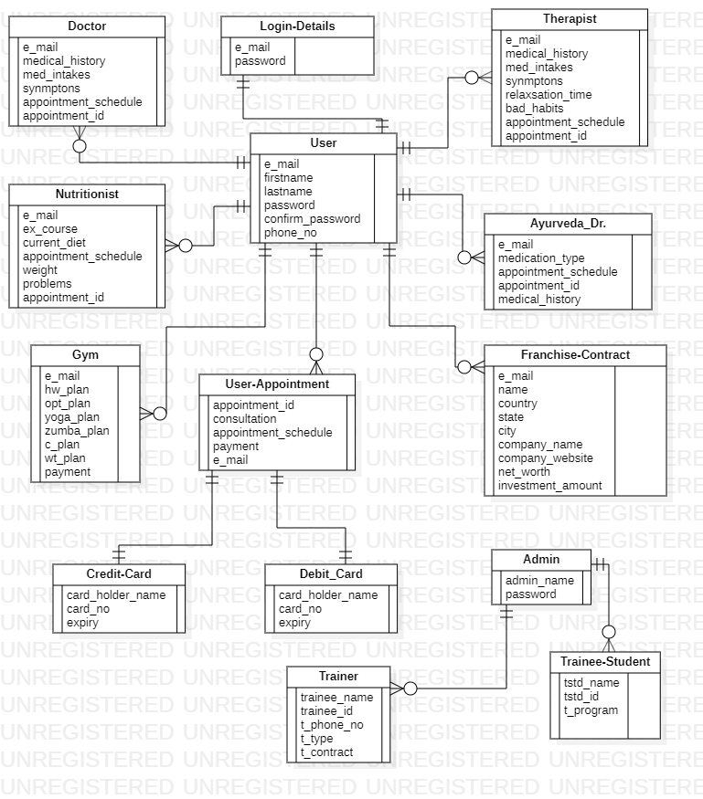

Figure 3.3 : ER Diagram

**Activity Diagram:**

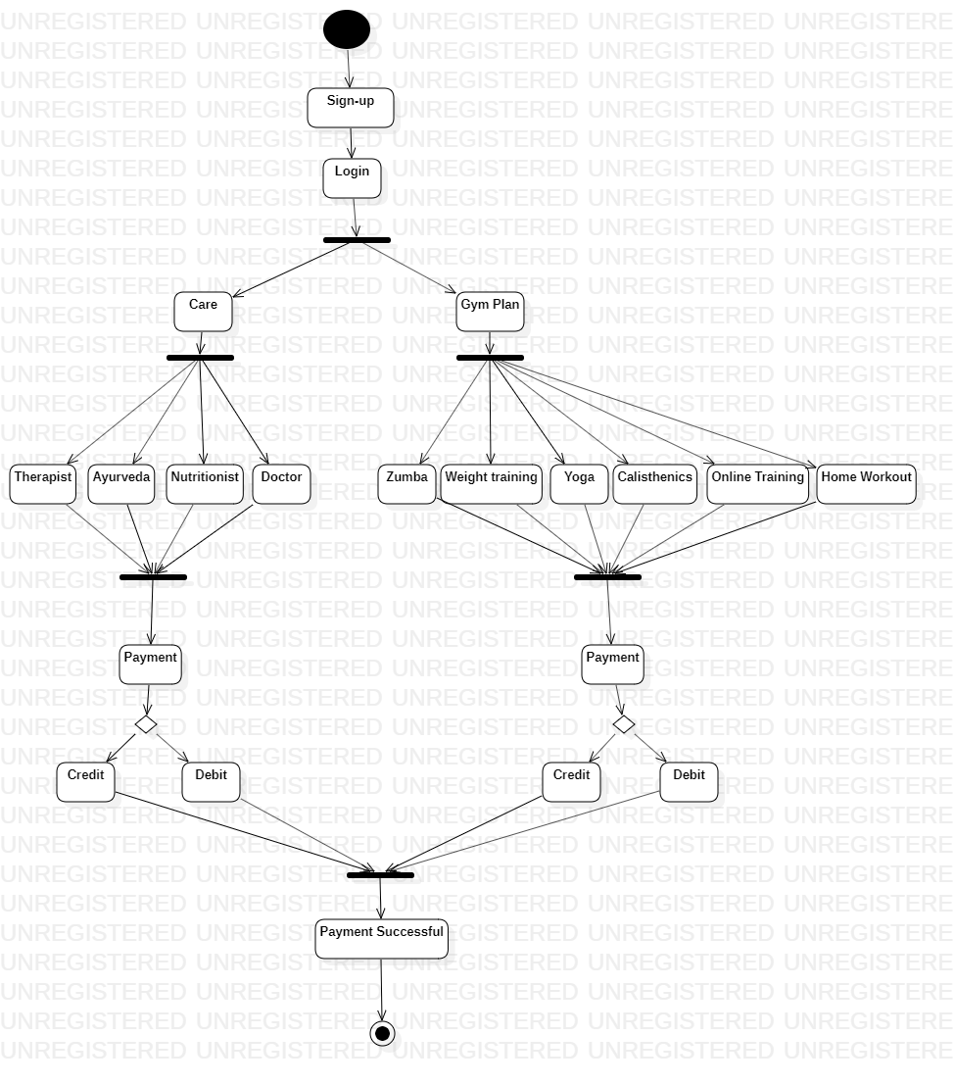

Figure 3.4 : Activity Diagram

**Use Case Diagram:**

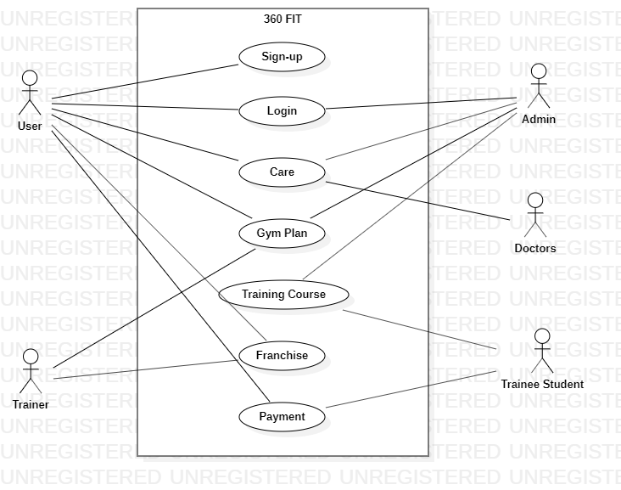

Figure 3.5 : Use Case Diagram

# **Chapter 4: System Design**

# **Basic Modules:**

* Home
* Care
* Gym Plan
* About
* Franchise
* Contact Us
* Login
* Sign-up
* News
* Training

# **Data Design:**

**Admin Table:**

|  |  |  |  |
| --- | --- | --- | --- |
| Column Name | Data Type | Key | Allow Null |
| Admin_name | Varchar(100) | PK | No |
| Password | Varchar(100) | - | No |

**User Table:**

|  |  |  |  |
| --- | --- | --- | --- |
| Column Name | Data Type | Key | Allow Null |
| e_mail | Varchar(100) | PK | No |
| firstname | Varchar(100) | - | No |
| lastname | Varchar(100) | - | No |
| password | Varchar(100) | - | No |
| confirm_password | Varchar(100) | - | No |
| phone_no | Int | - | No |

**Login Table:**

|  |  |  |  |
| --- | --- | --- | --- |
| Column Name | Data Type | Key | Allow Null |
| e_mail | Varchar(100) | FK | No |
| password | Varchar(100) | - | No |

**Doctor Table:**

|  |  |  |  |
| --- | --- | --- | --- |
| Column Name | Data Type | Key | Allow Null |
| e_mail | Varchar(100) | FK | No |
| medical_history | Varchar(100) | - | No |
| med_intake | Varchar(100) | - | No |
| synmptoms | Varchar(100) | - | No |
| appointment_schedule | Varchar(100) | - | No |
| appoinement_id | Int | PK | No |

**TherapistTable:**

|  |  |  |  |
| --- | --- | --- | --- |
| Column Name | Data Type | Key | Allow Null |
| e_mail | Varchar(100) | FK | No |
| medical_history | Varchar(100) | - | No |
| med_intakes | Varchar(100) | - | No |
| synmptons | Varchar(100) | - | No |
| relaxation_time | Varchar(100) | - | No |
| bad_habits | Varchar(100) | - | No |
| appointment_schedule | Varchar(100) | - | No |
| appointment_id | Varchar(100) | PK | No |

**Ayurved_Dr Table:**

|  |  |  |  |
| --- | --- | --- | --- |
| Column Name | Data Type | Key | Allow Null |
| e_mail | Varchar(100) | FK | No |
| medication_type | Varchar(100) | - | No |
| appointment_schedule | Varchar(100) | - | No |
| appointment_id | Varchar(100) | PK | No |
| medical_history | Varchar(100) | - | No |

**Nutritionist Table:**

|  |  |  |  |
| --- | --- | --- | --- |
| Column Name | Data Type | Key | Allow Null |
| e_mail | Varchar(100) | FK | No |
| ex_course | Varchar(100) | - | No |
| current_diet | Varchar(100) | - | No |
| appointment_schedule | Varchar(100) | - | No |
| weight | Int | - | No |
| problems | Varchar(100) | - | No |
| appointment_id | Varchar(100) | PK | No |

**User Appointment Table:**

|  |  |  |  |
| --- | --- | --- | --- |
| Column Name | Data Type | Key | Allow Null |
| appointment_id | Varchar(100) | PK | No |
| consultation | Varchar(100) | - | No |
| appointment_schedule | Varchar(100) | - | No |
| payment | Varchar(100) | - | No |
| e_mail | Varchar(100) | FK | No |

**Gym Table:**

|  |  |  |  |
| --- | --- | --- | --- |
| Column Name | Data Type | Key | Allow Null |
| e_mail | Varchar(100) | FK | Yes |
| hw_plan | Varchar(100) | - | Yes |
| opt_plan | Varchar(100) | - | Yes |
| yoga_plan | Varchar(100) | - | Yes |
| zumba_plan | Varchar(100) | - | Yes |
| c_plan | Varchar(100) | - | Yes |
| wt_plan | Varchar(100) | - | Yes |
| payment | Varchar(100) | - | No |

**Franchise Table:**

|  |  |  |  |
| --- | --- | --- | --- |
| Column Name | Data Type | Key | Allow Null |
| e_mail | Varchar(100) | FK | No |
| name | Varchar(100) | - | No |
| country | Varchar(100) | - | No |
| state | Varchar(100) | - | No |
| city | Varchar(100) | - | No |
| company_name | Varchar(100) | - | Yes |
| company_website | Varchar(100) | - | Yes |
| networth | Varchar(100) | - | No |
| investment_amount | Varchar(100) | - | No |

**Debit card:**

|  |  |  |  |
| --- | --- | --- | --- |
| Column Name | Data Type | Key | Allow Null |
| card_holder_name | Varchar(100) | - | No |
| card_no | Varchar(100) | PK | No |
| expiry | Varchar(100) | - | No |

**Credit card:**

|  |  |  |  |
| --- | --- | --- | --- |
| Column Name | Data Type | Key | Allow Null |
| card_holder_name | Varchar(100) | - | No |
| card_no | Varchar(100) | PK | No |
| expiry | Varchar(100) | - | No |

**Trainer:**

|  |  |  |  |
| --- | --- | --- | --- |
| Column Name | Data Type | Key | Allow Null |
| trainer_name | Varchar(100) | - | No |
| trainer_id | Varchar(100) | PK | No |
| t_phone_no | Varchar(100) | - | No |
| t_type | Varchar(100) | - | No |
| t_contract | Varchar(100) | - | No |

**Trainee Student:**

|  |  |  |  |
| --- | --- | --- | --- |
| Column Name | Data Type | Key | Allow Null |
| tstd_name | Varchar(100) | - | No |
| tstd_id | Varchar(100) | PK | No |
| t_program | Varchar(100) | - | No |

# **User Interface Design:**





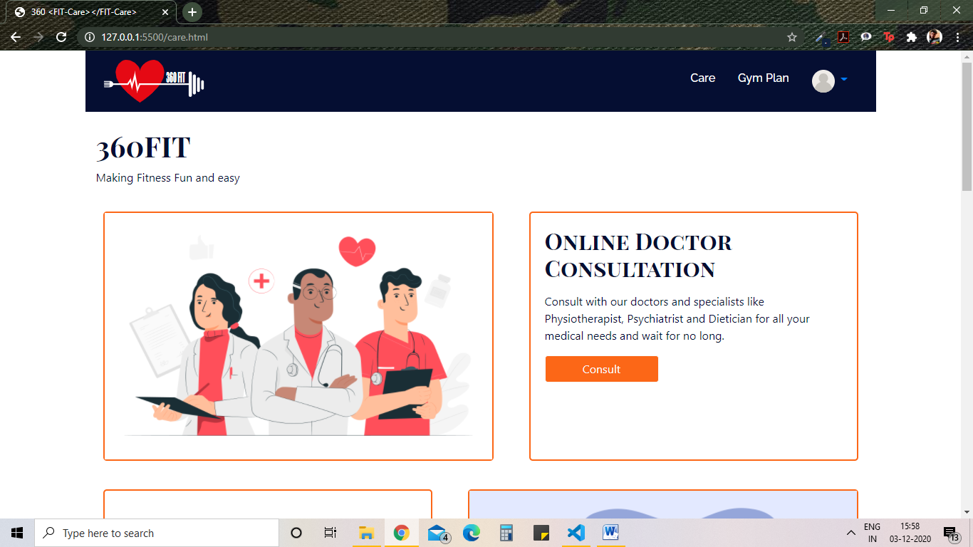

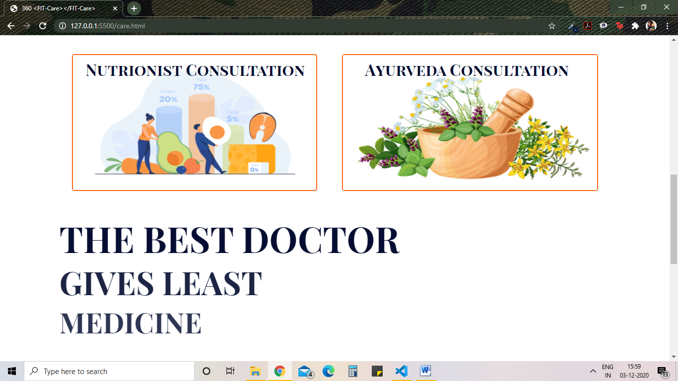

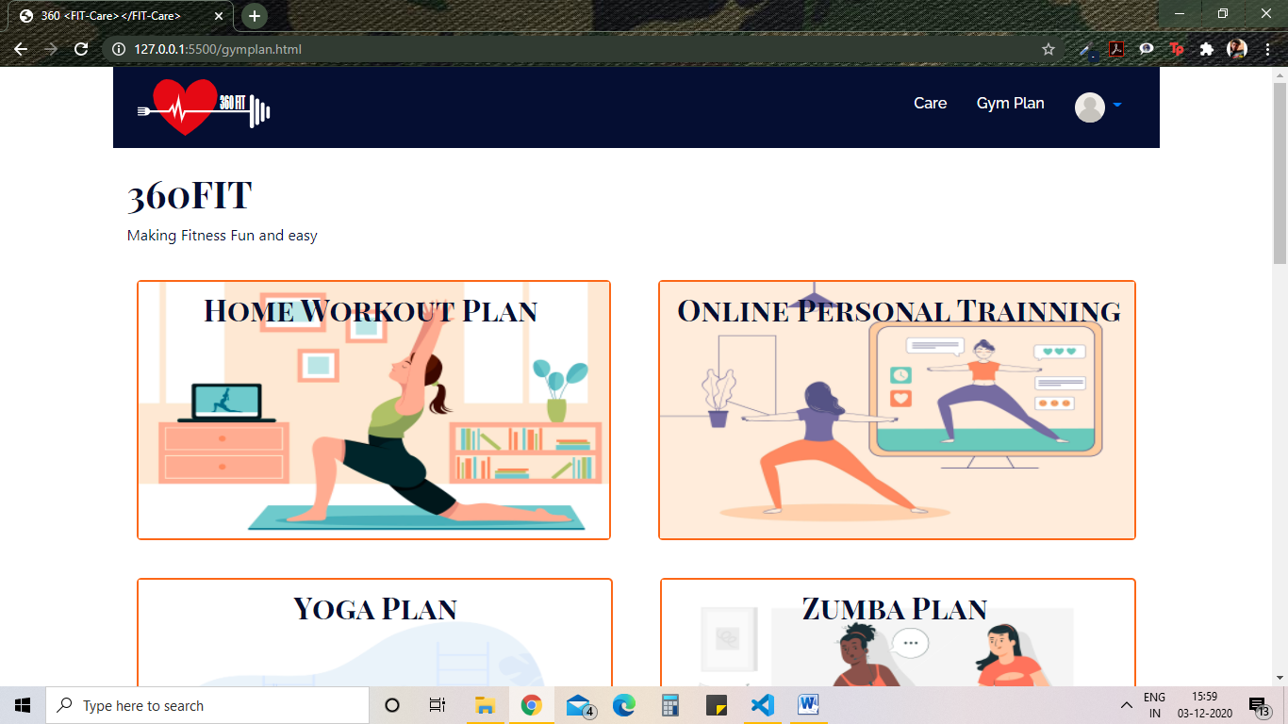

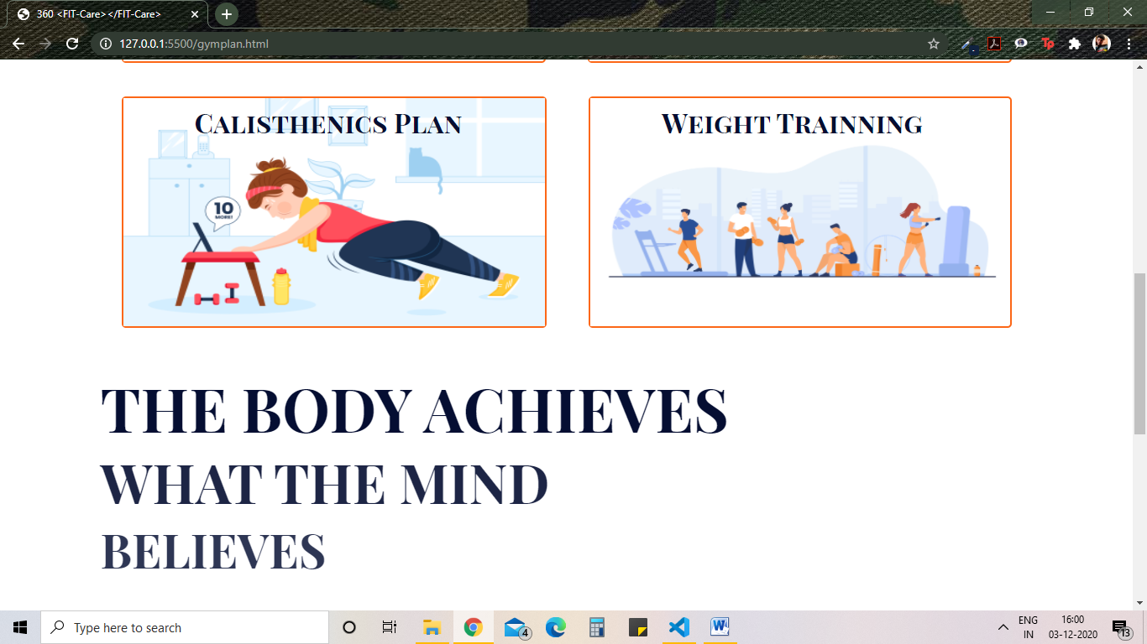

# **References**

[1] <https://stackoverflow.com/>

[2] <https://www.w3schools.com/>

[3] <https://dribbble.com/>